UPHire HomePage

The UpHire Home has 5 modules on page

Basically

On Header,

It has 4 tabs named – About UpHire, How it work, Projects,Marketplace & Registration option

After Header,there is slider – it contains 3-4 sliders which randomly rotate on page

There is one unmovable searchbar on slider section.

Using search bar ,

Client can search for freelancer for their project (skillwise)

Freelancer can search for project (skillwise).

Student can search for projects & jobs.

After sliderbar, there is main content 1 ,

On this section, visitor can check for several services which is provided by the company Uphire.

Main content 2 ,

On this section, visitor can check for top rated IT professionals for their project need. Here we will showcase the freelancers profiles skilllwise.

Main content 3,

On this section, visitor can view new IT Talent/freshers profile, here in this section, the student profile will be in showcase who just recently clear exam on the portal.

After content part, there is Footer,

In footer section, we will show case 3 tab contents for about Uphire,contact & share button.

**For Client**

Using Registration form, Client will be able to register on the website.

Here client can be able to register through registration form. Or they are also able to register through their social media account.

e.g.

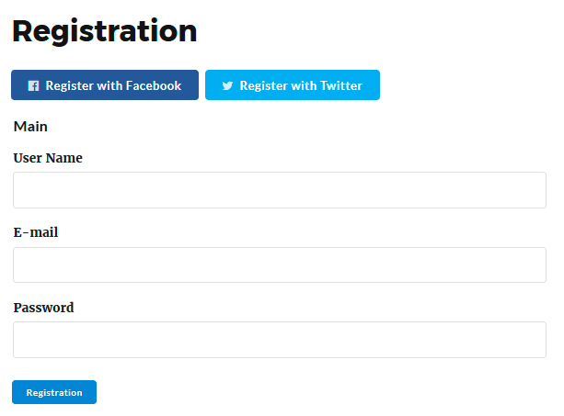

After Registration, the welcome mail will be sent by portal to registered mail id.

After registration do not forget to verify the email address. To verify email address – verification mail will be sent to the portal & using verification mail link account will be verify.

**After login on portal.**

Client will be able to view Profile dashboard.

On profile dashboard , they can be able to update their company biography(profile description) .

He can be upload personal details,biography,professional detail,education detail,work gallery & technology areas.

Personal detail includes the table attributes,

Unique id,username,email,alternative email,password,mobile number

biography detail includes the attributes,

Unique id,firstname,lastname,company name,company description,job role,address,pin code/zipcode,photo

Professional detail includes the attributes,

Unique id,company name,job role,description,start date,end date,job location

Education detail includes the attributes,

Unique id,college/school/university name,location,education type,field name,course name,start date,end date,description

Work gallery table includes the attributes,

Unique id,Project name,project category,project description,start date,end date,project image,skills

All these tables are connected with **personal detail** table through unique id (we need to specify unique id for each table so that we can combine all the table with personal detail using it’s primary key )

After updation of the profile dashboard (about his profile),

Client can go for Project Posting.

On same profile dashboard of client, he can post project using Post Project button.

To post project we have project posting form,

Using project posting form, he can able to post project on the portal.

To post project.

He need to insert some project information in the form that includes, project title,project description,timeline budget or hourly rate ,start date end date.

**For Project posting**

Project table includes the attributes,

Unique id,project title,project desctiption,project category,budget,hourly,timeline,start date,end date,date & time,project amount,actual amount,rate(%) fees,remain total amount

Here date&time attribute is default kind of attribute so that it will be automatically generate the date & time of project post which basically visible on job post

e.g.

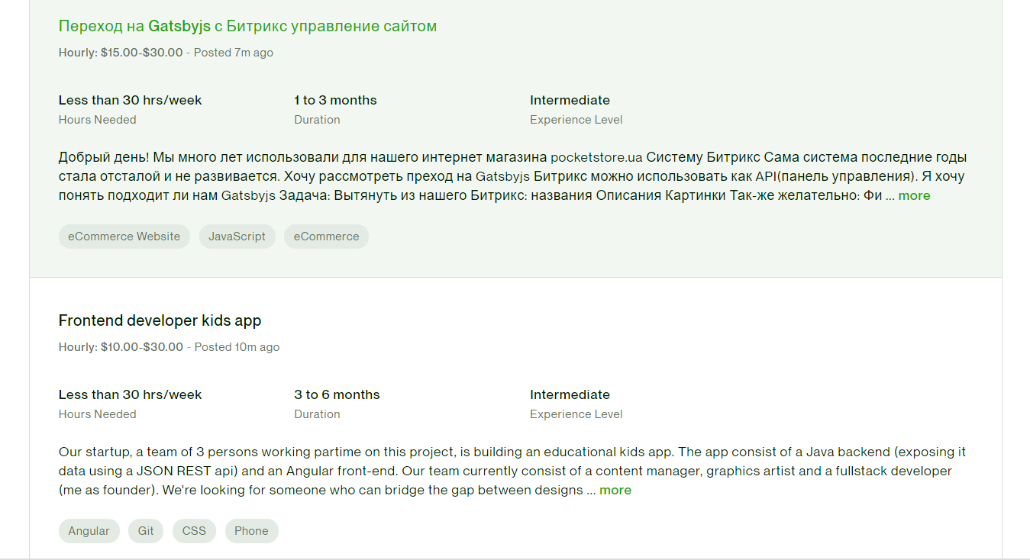

Here client can be able to post project on hourly bases or on fixed budget bases.

When client post any project on the portal,he can choose category either he want to post project for freelancer or for student/fresher or for both.

e.g. <https://www.upwork.com/resources/how-to-post-job-on-upwork>

on this portal, while posting project , the budget of client is decided by the client i.e. project amount but actual amount is proposed by freelancer , after both of the amount , the fees of project posting amount need to be pay by client for project posting.

e.g.

budget = $ 100

Actual budget = $ 100 depends on freelance proposal amount

Fees (default) = $20 decided by portal

So the total actual project amount = $80 auto calculated for project budget.

So $80 will be paid to freelancer.

He can be able to view all his job posting list on profile & list of proposals on respective project post.

He can be able to send text message using send message button to the freelancer. And based on his personal discussion he can be able to hire freelancer by awarding project.

Once the project awarded, he can view the working project on his workzone.

After completion of work he can generate invoice & send payment to the freelancer.

**Finance & Report (for client/freelancer/Student)**

The all payment conversation & workzone will be visible on finance & report section of the profile.

Here we have facilities of the UPHire Wallet, it shows the recent money activity on the portal.

To hire for any project client need to submit the project amount on portal (portal store in escrow) & release it once work get done & invoice generated.

Invoice generated from project table,

Invoice table include the attributes from project table

Unique id, Invoice number,project title,project,start date, end date, date& time,project amount,actual amount,fees, remain total amount.

The invoice amount will generated after deduction of complete charge sheet (including portal amount & escrow charge)

**For payment process**,

Client will be able to insert bank detail,card detail,paypal,UPI id detail to his profile.

Bank table includes the attribues,

Unique id,bank name,location,IFSC code,address,pin code,bank account number,confirm bank account number

Card table includes the attributes,

Unique id,card number,expire date,securitycode(CVV),status(active/inactive)

Other

**Paypal**

* Paypal email id

**Payoneer**

* Payoneer email id

**UPI**

* Enter UPI ID
* Enter UPI number

All these tables are connected with client personal detail id so that we can recognize each unique user and their bank accounts

**To Post Job on portal,**

Using job post form client will be able to post the job on portal.

For that Client need to add the job title, description, duration & salary,job type-part time/full time,location

**For job posting,**

Job table includes the attribues,

Unique id,job title,job description,duration ,salary,job type,location,date & time

Here date & time is detaulf job posting time which will be visible on job post so that student can recognise the posting time.

He can be able to view his job posting & list of appliers

He can be able to contact the student through portal using send message button.

He can hire for offline or online job needs.

**Create Team,**

Using create team option, client can generate own team through portal, to create team, he need to send the invitation to join his team for specific project need.

After sending the invitation, he can see the list of freelancer & students who accepted his invitation, he can then send examination to qualify the worker in his team.

The people who cleared the exam, client will be able to contact that worker, & after discussion through inbox, he can be able to allocate the work position to the freelancer/student for specific project work.

The job post,create team are premium services – to get the advantage of it , client need to purchase specific subscription plan.

Subscription table includes the attributes

**Subscription**

* Unique id
* Client id
* Freelancer id
* Student id
* Plan A
* Plan B
* Plan C
* Status

On the portal, client can not be post more than 5 post in free of cost, for further job posting he need to purchase specific subscription plan, without subscription he can not be able to view student resume file and many more.

**For Freelancer**

Using Registration form, Freelancer will be able to register on the website.

Here client can be able to register through registration form. Or they are also able to register through their social media account.

e.g.



After Registration, the welcome mail will be sent by portal to registered mail id.

After registration do not forget to verify the email address. To verify email address – verification mail will be sent to the portal & using verification mail link account will be verify.

**After login on portal.**

Freelancer will be able to view Profile dashboard.

On profile dashboard , they can be able to update their personAL biography(profile description) .

He can be upload personal details,biography,professional detail,education detail,work gallery & technology areas.

Personal detail includes the table attributes,

Unique id,username,email,alternative email,password,mobile number

biography detail includes the attributes,

Unique id,firstname,lastname,company name,company description,job role,address,pin code/zipcode,photo

Professional detail includes the attributes,

Unique id,company name,job role,description,start date,end date,job location

Education detail includes the attributes,

Unique id,college/school/university name,location,education type,field name,course name,start date,end date,description

Work gallery table includes the attributes,

Unique id,Project name,project category,project description,start date,end date,project image,skills

All these tables are connected with **personal detail** table through unique id (we need to specify unique id for each table so that we can combine all the table with personal detail using it’s primary key )

After updation of the profile dashboard (about his profile),

Freelancer can go for Project module.

Freelancer will be able to view list of projects categorieswise and the skill wise as whatever he mentioned on his profile.

By clicking on project, he can read project title & description , then he can be able to propose the amount based on his personal experience on hourly bases or on fix rate bases.

He need to submit his personal terms & project cost for the project proposal something like same way as in Upwork.

Once you do send proposal on project he can be able to edit or view his own project proposal.

When he get message from project client from proposed project then only he can be able to response for client. He can not be able to send direct message to client without getting message from client.

If he get hired for respective project, the should be able to view on working stage in his workspace.

He can be able view project report in his project includes the project timeframe,working hours etc… he can be able to increase timeframe if require.

After completion of the project he can create invoice for project and send notification to project client.

Once client mark the project as completed he can be able receive & withdraw the amount from portal only .

He can able to give feedback rating to client for project. The same way client.

**For student**

Using Registration form, Freelancer will be able to register on the website.

Here student can be able to register through registration form. Or they are also able to register through their social media account.

e.g.



After Registration, the welcome mail will be sent by portal to registered mail id.

After registration do not forget to verify the email address. To verify email address – verification mail will be sent to the portal & using verification mail link account will be verify.

**After login on portal.**

student will be able to view Profile dashboard.

On profile dashboard , they can be able to update their personAL biography(profile description) .

He can be upload personal details,biography,professional detail,education detail,work gallery & technology areas.

Personal detail includes the table attributes,

Unique id,username,email,alternative email,password,mobile number

biography detail includes the attributes,

Unique id,firstname,lastname,company name,company description,job role,address,pin code/zipcode,photo

Professional detail (if any)includes the attributes,

Unique id,company name,job role,description,start date,end date,job location

Education detail includes the attributes,

Unique id,college/school/university name,location,education type,field name,course name,start date,end date,description,resume

Work gallery table includes the attributes,

Unique id,Project name,project category,project description,start date,end date,project image,skills

All these tables are connected with **personal detail** table through unique id (we need to specify unique id for each table so that we can combine all the table with personal detail using it’s primary key )

After updation of the profile dashboard (about his profile),

student can go for Project module.

student will be able to view list of projects categorieswise and the skill wise as whatever he mentioned on his profile.

By clicking on project, he can read project title & description , then he can be able to propose the amount based on his personal experience on hourly bases or on fix rate bases.

He need to submit his personal terms & project cost for the project proposal something like same way as in Upwork.

Once you do send proposal on project he can be able to edit or view his own project proposal.

When he get message from project client from proposed project then only he can be able to response for client. He can not be able to send direct message to client without getting message from client.

If he get hired for respective project, the should be able to view on working stage in his workspace.

He can be able view project report in his project includes the project timeframe,working hours etc… he can be able to increase timeframe if require.

After completion of the project he can create invoice for project and send notification to project client.

Once client mark the project as completed he can be able receive & withdraw the amount from portal only .

student can go for Job module.

student will be able to view list of JObs categorieswise and the skill wise as whatever he mentioned on his profile.

By clicking on Job Post, he can read job title & job responsibilities.

Job post mainly includes the Job title, job description,timeframe (suppose for 6 month/1 year/long term etc), full time/part time & also includes the monthly/weekly salary details,location-offline/online etc

Student can be able to apply for the job post with resume. If their job application will selected by client he will contact student on portal through inbox messages.

**UPHire Wallet**

Uphire wallet includes the real time money matter transaction detail in number form. Whatever credit or debit occurs on portal.

To submit money from bank to portal or from portal to bank minght takes some hours or days but real time activity should be visible on uphire wallet.

**Setting**

On setting module, the summary,account setting & logout option is given.

In summary , list of applied job proposals with number of bids should be visible so that one can check their activity on portal.

**Payment Integration**

To manage payment Integration,

Specially to manage money matter between client & freelancer, we are going to use escrow services,

While posting project on portal some amount need to be escrow on job post, once work get done escrow will release the payment for specific account.

**Subscription**

On our portal we have give some free bids to apply for the job post or to do project proposals, for freelancer & student

If they want any more bids to do activity on portal they need to buy subscription plans from portal.